David Olson

Project 3 Whiteboard Experience

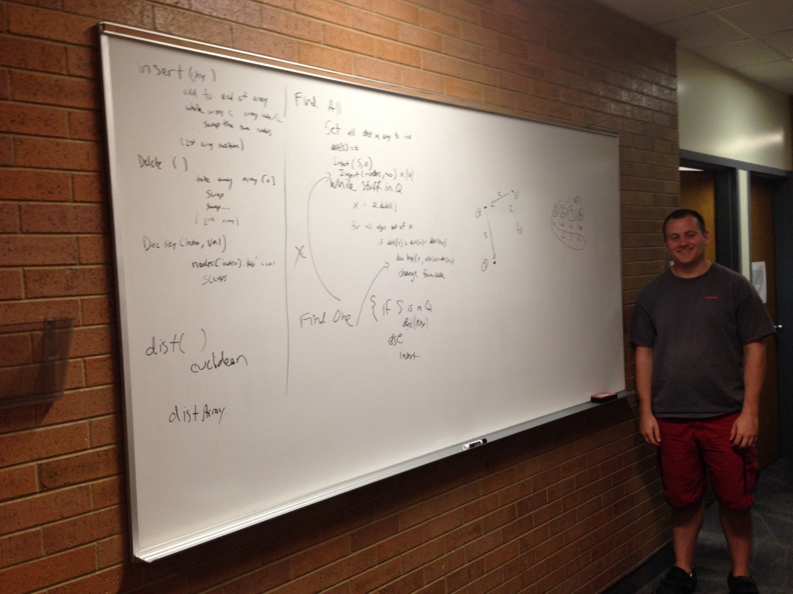

Yes, this is a horrible angle for a picture. But that 3rd level Talmage hallway is so skinny! The left part of the whiteboard has functions for the priority queue: insert, delete, decrease key. It also has a possible distance function if needed. The center portion is Dijkstra’s algorithm. I wrote the Find All pseudocode, then pointed out a few areas where Find One would be different. The right section of the board has a small example pointset, and the priority queue that would be created in solving that problem. I’m in the shadows off to the right(ok a bit of an exaggeration)